WindowExpress Project Tree – Restoration
The information shown to the left of the WindowExpress screen displays the most recently viewed or created quotes by the user on the current computer. The Project Tree is computer specific and not user specific. Various events occur that require project tree restoration. Some of these include: the project tree view has been deleted, quoting activity which occurred on a different computer, or WindowExpress has been downloaded on a new computer.
Follow the steps below to obtain your desired Project Tree display.
- Select either the Search and Find Quote or Find Quote
- Scroll down to the User Name and Creation Date fields
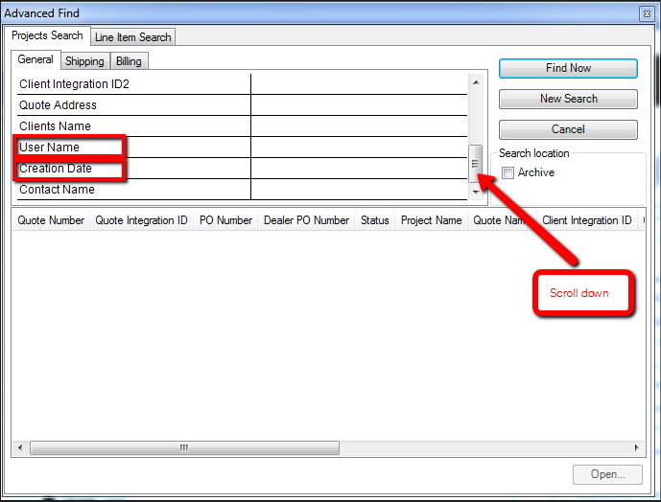
- User Name field - Select from the drop-down field or input your user name

Note: If the User Name is shared by various personnel, the search criteria will need to be more specific. If the search criteria are not specific, all quotes input by the shared User Name will display. Identifying the quotes desired will be difficult.

- Narrow down the results by adding information in additional fields such as project name, PO Number, Quote Status, etc.

- Creation Date field – select a date range
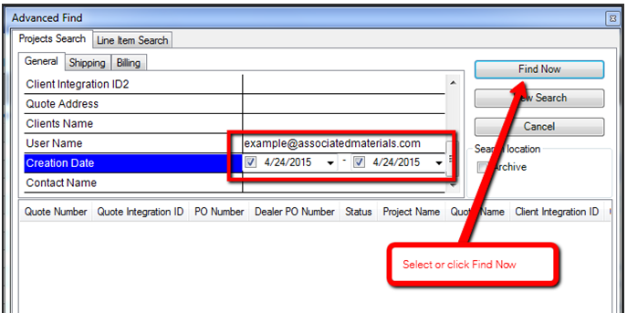
- All quotes created for this user and time range will be displayed in the box below:

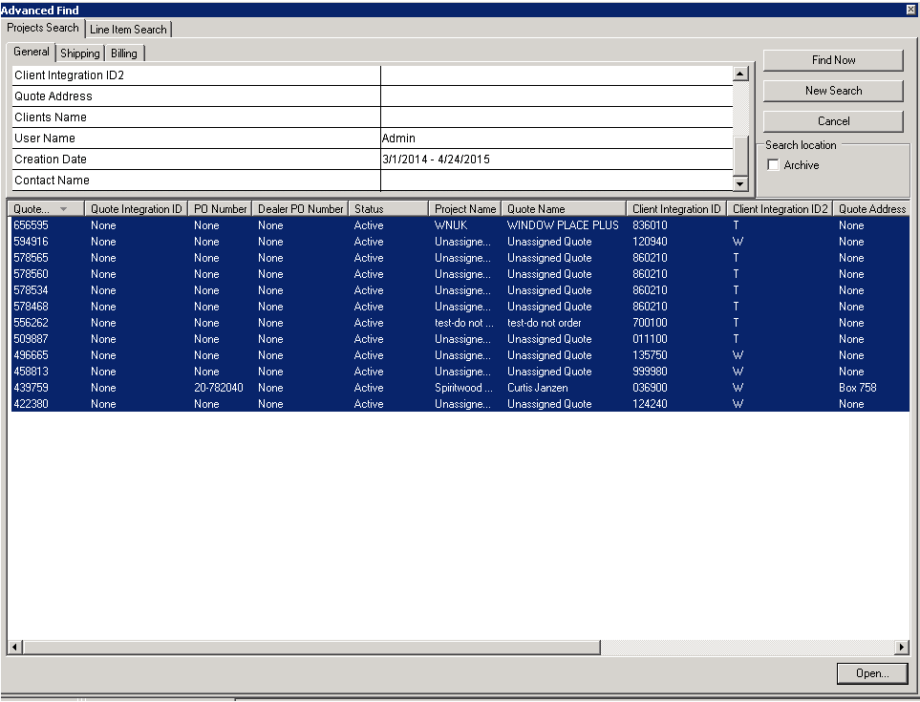

- Selecting all quotes
  - Hold the shift button
  - Click on the last quote in the listing
  - Click the Open button

- Select specific quotes
  - Hold down the Control button (Ctrl)
  - Click on the desired quotes
  - Click the Open button

- The First two quotes will open and if more than two quotes were selected, a message will advise that the maximum number has been reached. This means that only two quotes can be open simultaneously.

- All remaining quotes selected will display in the Project Tree

