

**WindowExpress Log Error Resolution**

If you are experiencing a problem with logging in to WindowExpress, please try the following steps:

1)   Close the error and login box for WindowExpress. Close the WindowExpress Program and cancel out of the Login box.

2)    Right click on the WindowExpress icon on your desktop.

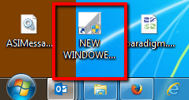

3)      Select ***Properties***

4) Microsoft Users– select the process according to the version you are running on your computer:

1. Microsoft XP version and newer:
   1. Microsoft has this version defaulted to “Hide extensions for known file types” shown below.

Some companies have chosen to change their default setting. The below steps will guide you to the file needed for the next steps.

* 1. Open the Folder Options in Control Panel

1. Click **Start**, and then click **Control Panel**.
2. Click **Appearance and Themes**, and then click **Folder Options**.
   1. Click on the **View** tab and **Advanced Settings**

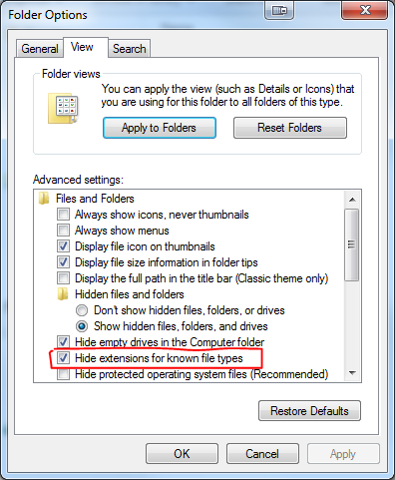

With the option **ON**, you will see this as the file names.

**\*This is the DEFAULT from Microsoft**

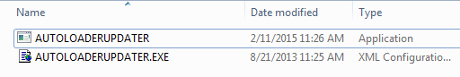

* 1. Select the file named “AUTOLOADERUPDATER” to run. Do not select the file named “AUTOLOADERUPDATER.EXE”.

With the option **OFF**, you will see these file names.

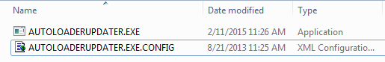

* 1. Select the file named “AUTOLOADERUPDATER.EXE”to run. Do not select the other option with “.CONFIG” at the end of the file extension.

1. Other Microsoft operating systems
   1. Find the button that says either “Open File Location” or “Find Target Location” and click on it. You will see a folder open to the location

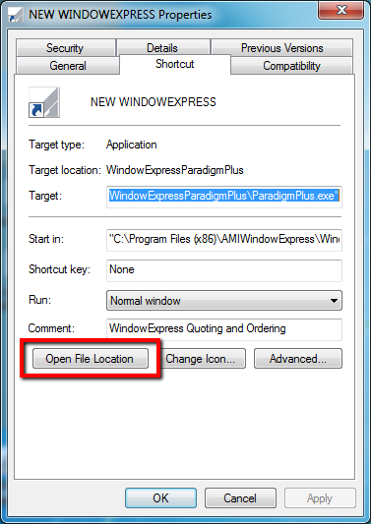

* 1. Look for the application file named “AutoloaderUpdater.exe” and double click it.  This will have a blue and green icon next to it.

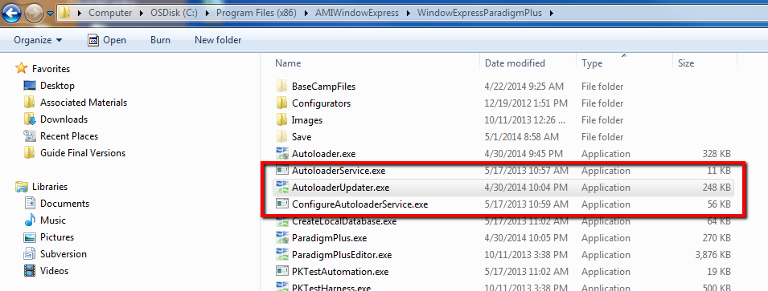

**NOTE**: There are 2 files titled “Autoloaderupdater.exe”. Select the file named “Autoloaderupdater.exe”. Do not select the file named “Autoloaderupdater.exe.config”. If you prefer, you can sort by clicking on the “Type” label at the top of the column to sort your files types alphabetically. Autoloaderupdater.exe is an application file. This will bring your file to the top of the list.

4)      You will be prompted to update autoloader. They should click “OK”.

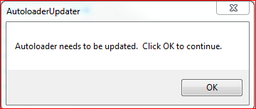

5)    The application will bring up the following login box:

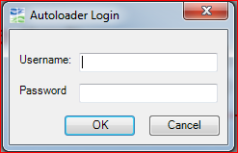

Fill in your WindowExpress credentials and click OK.

6)    After a minute the Autoloader Progress Bar should appear.

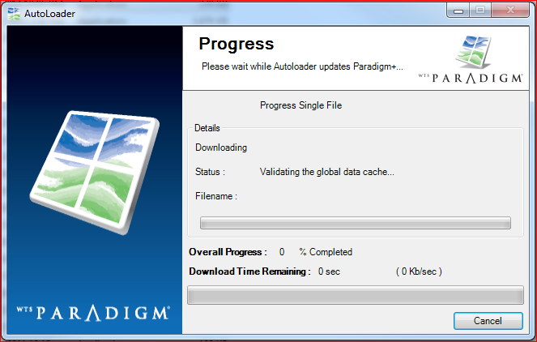

7) Once the update is complete, the program will open and you can begin ordering!

Please contact your Customer Service Representative if you are still experiencing issues.